1. named is hidden layers.

### Key concepts in a Neural Network

#### A. Neuron:

A Neuron is a single processing unit of a Neural Network which are connected to different other neurons in the network. These connections repersents inputs and ouputs from a neuron. To each of its connections, the neuron assigns a “weight” (W) which signifies the importance the input and adds a bias (b) term.

#### B. Activation Functions

The activation functions are used to apply non-linear transformation on input to map it to output. The aim of activation functions is to predict the right class of the target variable based on the input combination of variables. Some of the popular activation functions are Relu, Sigmoid, and TanH.

#### C. Forward Propagation

Neural Network model goes through the process called forward propagation in which it passes the computed activation outputs in the forward direction.

Z = W*X + b  
A = g(Z)

* g is the activation function
* A is the activation using the input
* W is the weight associated with the input
* B is the bias associated with the node

#### D. Error Computation:

The neural network learns by improving the values of weights and bias. The model computes the error in the predicted output in the final layer which is then used to make small adjustments the weights and bias. The adjustments are made such that the total error is minimized. Loss function measures the error in the final layer and cost function measures the total error of the network.

Loss = Actual_Value - Predicted_Value

Cost = Summation (Loss)

#### E. Backward Propagation:

Neural Network model undergoes the process called backpropagation in which the error is passed to backward layers so that those layers can also improve the associated values of weights and bias. It uses the algorithm called Gradient Descent in which the error is minimized and optimal values of weights and bias are obtained. This weights and bias adjustment is done by computing the derivative of error, derivative of weights, bias and subtracting them from the original values.

### Key components of Convolutional Neural Network.

**A. Convolutional layer:** In this layer, a kernel (or weight) matrix is used to extract low level features from the images. The kernel with its weights rotates over the image matrix in a sliding window fashion in order to obtained the convolved output. The kernel matrix behaves like a filter in an image extracting particular information from the original image matrix. During the colvolution process, The weights are learnt such that the loss function is minimized.

## Motivation

## 

## Introduction

Most of us last saw calculus in school, but derivatives are a critical part of machine learning, particularly deep neural networks, which are trained by optimizing a loss function. Pick up a machine learning paper or the documentation of a library such as [PyTorch](http://pytorch.org) and calculus comes screeching back into your life like distant relatives around the holidays. And it's not just any old scalar calculus that pops up---you need differential *matrix calculus*, the shotgun wedding of [linear algebra](https://en.wikipedia.org/wiki/Linear_algebra) and [multivariate calculus](https://en.wikipedia.org/wiki/Multivariable_calculus).

Well... maybe *need* isn't the right word; Jeremy's courses show how to become a world-class deep learning practitioner with only a minimal level of scalar calculus, thanks to leveraging the automatic differentiation built in to modern deep learning libraries. But if you really want to really understand what's going on under the hood of these libraries, and grok academic papers discussing the latest advances in model training techniques, you'll need to understand certain bits of the field of matrix calculus.

For example, the activation of a single computation unit in a neural network is typically calculated using the dot product (from linear algebra) of an edge weight vector w with an input vector x plus a scalar bias (threshold): . Function is called the unit's *affine function* and is followed by a [rectified linear unit](https://goo.gl/7BXceK), which clips negative values to zero: . Such a computational unit is sometimes referred to as an “artificial neuron” and looks like:

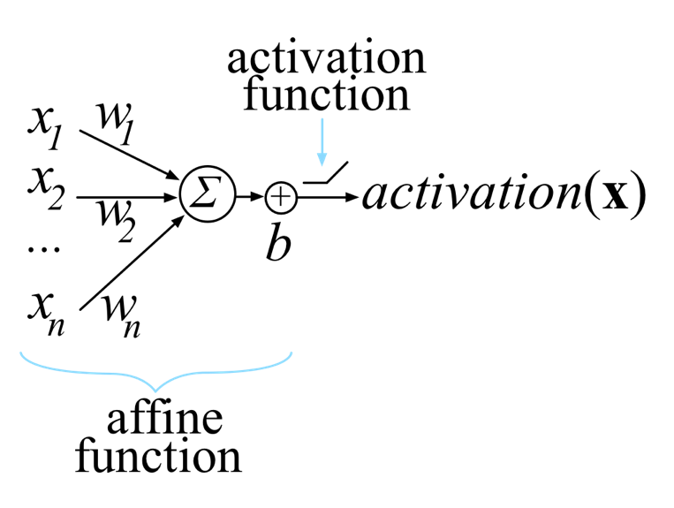

Neural networks consist of many of these units, organized into multiple collections of neurons called *layers*. The activation of one layer's units become the input to the next layer's units. The activation of the unit or units in the final layer is called the network output.

*Training* this neuron means choosing weights w and bias b so that we get the desired output for all N inputs x. To do that, we minimize a *loss function* that compares the network's final with the (desired output of x) for all input x vectors. To minimize the loss, we use some variation on gradient descent, such as plain [stochastic gradient descent](https://en.wikipedia.org/wiki/Stochastic_gradient_descent) (SGD), SGD with momentum, or [Adam](https://en.wikipedia.org/wiki/Stochastic_gradient_descent#Adam). All of those require the partial derivative (the gradient) of with respect to the model parameters w and b. Our goal is to gradually tweak w and b so that the overall loss function keeps getting smaller across all x inputs.

If we're careful, we can derive the gradient by differentiating the scalar version of a common loss function (mean squared error):

But this is just one neuron, and neural networks must train the weights and biases of all neurons in all layers simultaneously. Because there are multiple inputs and (potentially) multiple network outputs, we really need general rules for the derivative of a function with respect to a vector and even rules for the derivative of a vector-valued function with respect to a vector.

This article walks through the derivation of some important rules for computing partial derivatives with respect to vectors, particularly those useful for training neural networks. This field is known as *matrix calculus*, and the good news is, we only need a small subset of that field, which we introduce here. While there is a lot of online material on multivariate calculus and linear algebra, they are typically taught as two separate undergraduate courses so most material treats them in isolation. The pages that do discuss matrix calculus often are really just lists of rules with minimal explanation or are just pieces of the story. They also tend to be quite obscure to all but a narrow audience of mathematicians, thanks to their use of dense notation and minimal discussion of foundational concepts. (See the annotated list of resources at the end.)

In contrast, we're going to rederive and rediscover some key matrix calculus rules in an effort to explain them. It turns out that matrix calculus is really not that hard! There aren't dozens of new rules to learn; just a couple of key concepts. Our hope is that this short paper will get you started quickly in the world of matrix calculus as it relates to training neural networks. We're assuming you're already familiar with the basics of neural network architecture and training. If you're not, head over to [Jeremy's course](http://course.fast.ai) and complete part 1 of that, then we'll see you back here when you're done. (Note that, unlike many more academic approaches, we strongly suggest *first* learning to train and use neural networks in practice and *then* study the underlying math. The math will be much more understandable with the context in place; besides, it's not necessary to grok all this calculus to become an effective practitioner.)

*A note on notation*: Jeremy's course exclusively uses code, instead of math notation, to explain concepts since unfamiliar functions in code are easy to search for and experiment with. In this paper, we do the opposite: there is a lot of math notation because one of the goals of this paper is to help you understand the notation that you'll see in deep learning papers and books. At the [end of the paper](https://explained.ai/matrix-calculus/index.html#notation), you'll find a brief table of the notation used, including a word or phrase you can use to search for more details.

## The gradient of neuron activation

We now have all of the pieces needed to compute the derivative of a typical neuron activation for a single neural network computation unit with respect to the model parameters, w and b:

(This represents a neuron with fully connected weights and rectified linear unit activation. There are, however, other affine functions such as convolution and other activation functions, such as exponential linear units, that follow similar logic.)

Let's worry about max later and focus on computing and . (Recall that neural networks learn through optimization of their weights and biases.) We haven't discussed the derivative of the dot product yet, , but we can use the chain rule to avoid having to memorize yet another rule. (Note notation y not y as the result is a scalar not a vector.)

The dot product is just the summation of the element-wise multiplication of the elements: . (You might also find it useful to remember the linear algebra notation .) We know how to compute the partial derivatives of and but haven't looked at partial derivatives for . We need the chain rule for that and so we can introduce an intermediate vector variable u just as we did using the single-variable chain rule:

Once we've rephrased y, we recognize two subexpressions for which we already know the partial derivatives:

The vector chain rule says to multiply the partials:

To check our results, we can grind the dot product down into a pure scalar function:

Then:

Hooray! Our scalar results match the vector chain rule results.

Now, let , the full expression within the max activation function call. We have two different partials to compute, but we don't need the chain rule:

Let's tackle the partials of the neuron activation, . The use of the function call on scalar z just says to treat all negative z values as 0. The derivative of the max function is a piecewise function. When , the derivative is 0 because z is a constant. When , the derivative of the max function is just the derivative of z, which is :

An aside on broadcasting functions across scalars. When one or both of the max arguments are vectors, such as , we broadcast the single-variable function max across the elements. This is an example of an element-wise unary operator. Just to be clear:

For the derivative of the broadcast version then, we get a vector of zeros and ones where:

To get the derivative of the function, we need the chain rule because of the nested subexpression, . Following our process, let's introduce intermediate scalar variable z to represent the affine function giving:

The vector chain rule tells us:

which we can rewrite as follows:

and then substitute back in:

That equation matches our intuition. When the activation function clips affine function output z to 0, the derivative is zero with respect to any weight wi. When , it's as if the max function disappears and we get just the derivative of z with respect to the weights.

Turning now to the derivative of the neuron activation with respect to b, we get:

Let's use these partial derivatives now to handle the entire loss function.

## The gradient of the neural network loss function

Training a neuron requires that we take the derivative of our loss or “cost” function with respect to the parameters of our model, w and b. Because we train with multiple vector inputs (e.g., multiple images) and scalar targets (e.g., one classification per image), we need some more notation. Let

where , and then let

where yi is a scalar. Then the cost equation becomes:

Following our chain rule process introduces these intermediate variables:

Let's compute the gradient with respect to w first.

### The gradient with respect to the weights

From before, we know:

and

Then, for the overall gradient, we get:

To interpret that equation, we can substitute an error term yielding:

From there, notice that this computation is a weighted average across all xi in X. The weights are the error terms, the difference between the target output and the actual neuron output for each xi input. The resulting gradient will, on average, point in the direction of higher cost or loss because large ei emphasize their associated xi. Imagine we only had one input vector, , then the gradient is just . If the error is 0, then the gradient is zero and we have arrived at the minimum loss. If is some small positive difference, the gradient is a small step in the direction of . If is large, the gradient is a large step in that direction. If is negative, the gradient is reversed, meaning the highest cost is in the negative direction.

Of course, we want to reduce, not increase, the loss, which is why the [gradient descent](https://en.wikipedia.org/wiki/Gradient_descent) recurrence relation takes the negative of the gradient to update the current position (for scalar learning rate ):

Because the gradient indicates the direction of higher cost, we want to update x in the opposite direction.

### The derivative with respect to the bias

To optimize the bias, b, we also need the partial with respect to b. Here are the intermediate variables again:

We computed the partial with respect to the bias for equation previously:

For v, the partial is:

And for the partial of the cost function itself we get:

As before, we can substitute an error term:

The partial derivative is then just the average error or zero, according to the activation level. To update the neuron bias, we nudge it in the opposite direction of increased cost:

In practice, it is convenient to combine w and b into a single vector parameter rather than having to deal with two different partials: . This requires a tweak to the input vector x as well but simplifies the activation function. By tacking a 1 onto the end of x, , becomes .

This finishes off the optimization of the neural network loss function because we have the two partials necessary to perform a gradient descent.

## Summary

Hopefully you've made it all the way through to this point. You're well on your way to understanding matrix calculus! We've included a reference that s

Convolutional Neural Networks (CNN) are biologically-inspired variants of MLPs. From Hubel and Wiesel’s early work on the cat’s visual cortex [[Hubel68]](http://deeplearning.net/tutorial/references.html#hubel68), we know the visual cortex contains a complex arrangement of cells. These cells are sensitive to small sub-regions of the visual field, called a receptive field. The sub-regions are tiled to cover the entire visual field. These cells act as local filters over the input space and are well-suited to exploit the strong spatially local correlation present in natural images.

Additionally, two basic cell types have been identified: Simple cells respond maximally to specific edge-like patterns within their receptive field. Complex cells have larger receptive fields and are locally invariant to the exact position of the pattern.

The animal visual cortex being the most powerful visual processing system in existence, it seems natural to emulate its behavior. Hence, many neurally-inspired models can be found in the literature. To name a few: the NeoCognitron [[Fukushima]](http://deeplearning.net/tutorial/references.html#fukushima), HMAX [[Serre07]](http://deeplearning.net/tutorial/references.html#serre07) and LeNet-5 [[LeCun98]](http://deeplearning.net/tutorial/references.html#lecun98), which will be the focus of this tutorial.

## Sparse Connectivity

CNNs exploit spatially-local correlation by enforcing a local connectivity pattern between neurons of adjacent layers. In other words, the inputs of hidden units in layer **m** are from a subset of units in layer **m-1**, units that have spatially contiguous receptive fields. We can illustrate this graphically as follows:

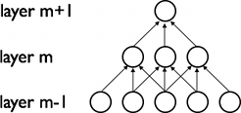

Imagine that layer **m-1** is the input retina. In the above figure, units in layer **m** have receptive fields of width 3 in the input retina and are thus only connected to 3 adjacent neurons in the retina layer. Units in layer **m+1** have a similar connectivity with the layer below. We say that their receptive field with respect to the layer below is also 3, but their receptive field with respect to the input is larger (5). Each unit is unresponsive to variations outside of its receptive field with respect to the retina. The architecture thus ensures that the learnt “filters” produce the strongest response to a spatially local input pattern.

However, as shown above, stacking many such layers leads to (non-linear) “filters” that become increasingly “global” (i.e. responsive to a larger region of pixel space). For example, the unit in hidden layer **m+1** can encode a non-linear feature of width 5 (in terms of pixel space).

## Shared Weights

In addition, in CNNs, each filter is replicated across the entire visual field. These replicated units share the same parameterization (weight vector and bias) and form a feature map.

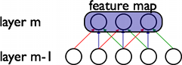

In the above figure, we show 3 hidden units belonging to the same feature map. Weights of the same color are shared—constrained to be identical. Gradient descent can still be used to learn such shared parameters, with only a small change to the original algorithm. The gradient of a shared weight is simply the sum of the gradients of the parameters being shared.

Replicating units in this way allows for features to be detected regardless of their position in the visual field. Additionally, weight sharing increases learning efficiency by greatly reducing the number of free parameters being learnt. The constraints on the model enable CNNs to achieve better generalization on vision problems.

## Details and Notation

A feature map is obtained by repeated application of a function across sub-regions of the entire image, in other words, by convolution of the input image with a linear filter, adding a bias term and then applying a non-linear function. If we denote the k-th feature map at a given layer as , whose filters are determined by the weights and bias , then the feature map is obtained as follows (for non-linearities):



Note

Recall the following definition of convolution for a 1D signal. .

This can be extended to 2D as follows: .

To form a richer representation of the data, each hidden layer is composed of multiple feature maps, . The weights of a hidden layer can be represented in a 4D tensor containing elements for every combination of destination feature map, source feature map, source vertical position, and source horizontal position. The biases can be represented as a vector containing one element for every destination feature map. We illustrate this graphically as follows:

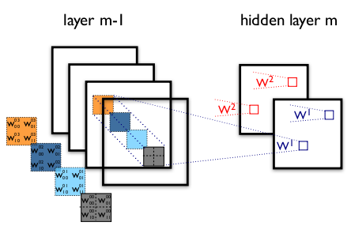

**Figure 1**: example of a convolutional layer

The figure shows two layers of a CNN. **Layer m-1** contains four feature maps. **Hidden layer m** contains two feature maps ( and ). Pixels (neuron outputs) in and (outlined as blue and red squares) are computed from pixels of layer (m-1) which fall within their 2x2 receptive field in the layer below (shown as colored rectangles). Notice how the receptive field spans all four input feature maps. The weights and of and are thus 3D weight tensors. The leading dimension indexes the input feature maps, while the other two refer to the pixel coordinates.

Putting it all together, denotes the weight connecting each pixel of the k-th feature map at layer m, with the pixel at coordinates (i,j) of the l-th feature map of layer (m-1).

**MaxPooling**

Another important concept of CNNs is *max-pooling,* which is a form of non-linear down-sampling. Max-pooling partitions the input image into a set of non-overlapping rectangles and, for each such sub-region, outputs the maximum value.

Max-pooling is useful in vision for two reasons:

1. By eliminating non-maximal values, it reduces computation for upper layers.
2. It provides a form of translation invariance. Imagine cascading a max-pooling layer with a convolutional layer. There are 8 directions in which one can translate the input image by a single pixel. If max-pooling is done over a 2x2 region, 3 out of these 8 possible configurations will produce exactly the same output at the convolutional layer. For max-pooling over a 3x3 window, this jumps to 5/8.

Since it provides additional robustness to position, max-pooling is a “smart” way of reducing the dimensionality of intermediate representations.

Max-pooling is done in Theano by way of theano.tensor.signal.pool.pool_2d. This function takes as input an N dimensional tensor (where N >= 2) and a downscaling factor and performs max-pooling over the 2 trailing dimensions of the tensor.

**Recurrent Neural Network**

**LSTM**

[LSTM Neural Networks](https://en.wikipedia.org/wiki/Long_short-term_memory), which stand for **L**ong **S**hort-**T**erm **M**emory, are a particular type of recurrent neural networks that got lot of attention recently within the machine learning community.

In a simple way, LSTM networks have some internal **contextual state cells**that act as long-term or short-term memory cells.  
The output of the LSTM network is **modulated** by the state of these cells. This is a very important property when we need the prediction of the neural network to depend on the **historical context** of inputs, rather than only on the very last input.

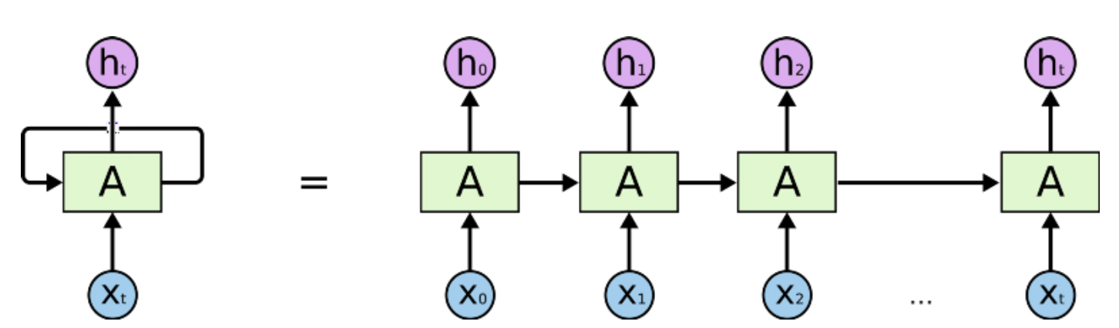

Humans don’t start their thinking from scratch every second. As you read this essay, you understand each word based on your understanding of previous words. You don’t throw everything away and start thinking from scratch again. Your thoughts have persistence.

Traditional neural networks can’t do this, and it seems like a major shortcoming. For example, imagine you want to classify what kind of event is happening at every point in a movie. It’s unclear how a traditional neural network could use its reasoning about previous events in the film to inform later ones.

Recurrent neural networks address this issue. They are networks with loops in them, allowing information to persist.

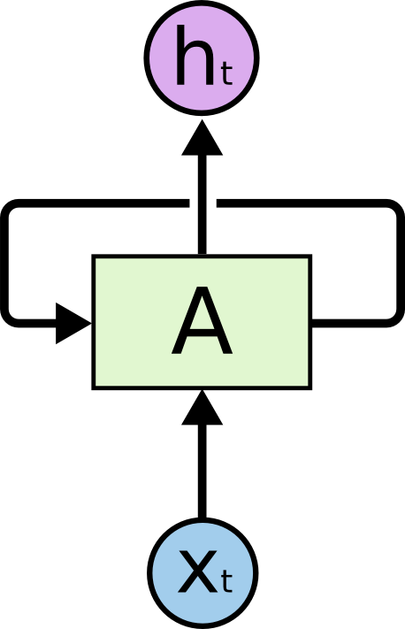

**Recurrent Neural Networks have loops.**

In the above diagram, a chunk of neural network, *A*

, looks at some input *xt* and outputs a value *ht*

. A loop allows information to be passed from one step of the network to the next.

These loops make recurrent neural networks seem kind of mysterious. However, if you think a bit more, it turns out that they aren’t all that different than a normal neural network. A recurrent neural network can be thought of as multiple copies of the same network, each passing a message to a successor. Consider what happens if we unroll the loop:

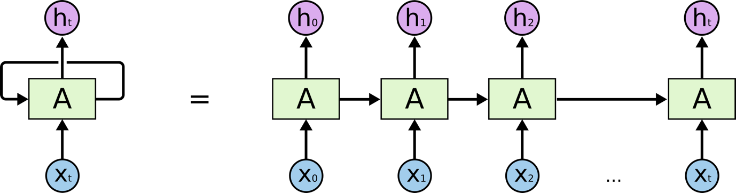

**An unrolled recurrent neural network.**

This chain-like nature reveals that recurrent neural networks are intimately related to sequences and lists. They’re the natural architecture of neural network to use for such data.

And they certainly are used! In the last few years, there have been incredible success applying RNNs to a variety of problems: speech recognition, language modeling, translation, image captioning… The list goes on. I’ll leave discussion of the amazing feats one can achieve with RNNs to Andrej Karpathy’s excellent blog post, [The Unreasonable Effectiveness of Recurrent Neural Networks](http://karpathy.github.io/2015/05/21/rnn-effectiveness/). But they really are pretty amazing.

Essential to these successes is the use of “LSTMs,” a very special kind of recurrent neural network which works, for many tasks, much much better than the standard version. Almost all exciting results based on recurrent neural networks are achieved with them. It’s these LSTMs that this essay will explore.

**The Problem of Long-Term Dependencies**

One of the appeals of RNNs is the idea that they might be able to connect previous information to the present task, such as using previous video frames might inform the understanding of the present frame. If RNNs could do this, they’d be extremely useful. But can they? It depends.

Sometimes, we only need to look at recent information to perform the present task. For example, consider a language model trying to predict the next word based on the previous ones. If we are trying to predict the last word in “the clouds are in the *sky*,” we don’t need any further context – it’s pretty obvious the next word is going to be sky. In such cases, where the gap between the relevant information and the place that it’s needed is small, RNNs can learn to use the past information.

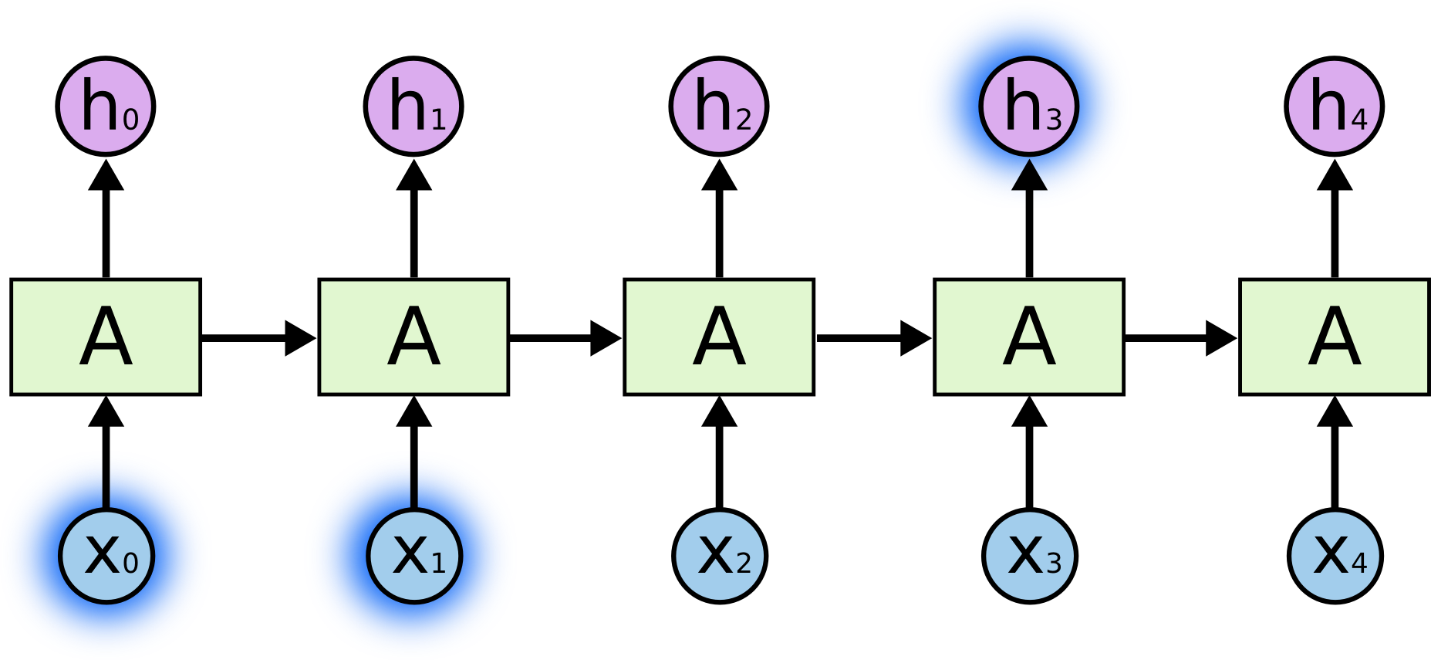

But there are also cases where we need more context. Consider trying to predict the last word in the text “I grew up in France… I speak fluent *French*.” Recent information suggests that the next word is probably the name of a language, but if we want to narrow down which language, we need the context of France, from further back. It’s entirely possible for the gap between the relevant information and the point where it is needed to become very large.

Unfortunately, as that gap grows, RNNs become unable to learn to connect the information.

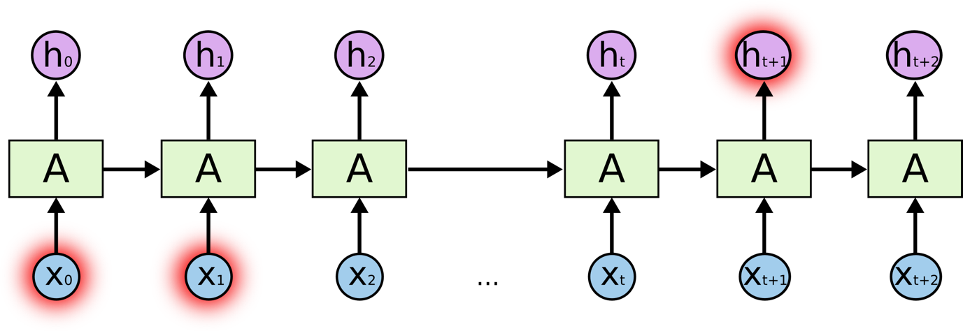

In theory, RNNs are absolutely capable of handling such “long-term dependencies.” A human could carefully pick parameters for them to solve toy problems of this form. Sadly, in practice, RNNs don’t seem to be able to learn them. The problem was explored in depth by [Hochreiter (1991) [German]](http://people.idsia.ch/~juergen/SeppHochreiter1991ThesisAdvisorSchmidhuber.pdf) and [Bengio, et al. (1994)](http://www-dsi.ing.unifi.it/~paolo/ps/tnn-94-gradient.pdf), who found some pretty fundamental reasons why it might be difficult.

Thankfully, LSTMs don’t have this problem!

**LSTM Networks**

Long Short Term Memory networks – usually just called “LSTMs” – are a special kind of RNN, capable of learning long-term dependencies. They were introduced by [Hochreiter & Schmidhuber (1997)](http://www.bioinf.jku.at/publications/older/2604.pdf), and were refined and popularized by many people in following work.[1](http://colah.github.io/posts/2015-08-Understanding-LSTMs/#fn1) They work tremendously well on a large variety of problems, and are now widely used.

LSTMs are explicitly designed to avoid the long-term dependency problem. Remembering information for long periods of time is practically their default behavior, not something they struggle to learn!

All recurrent neural networks have the form of a chain of repeating modules of neural network. In standard RNNs, this repeating module will have a very simple structure, such as a single tanh layer.

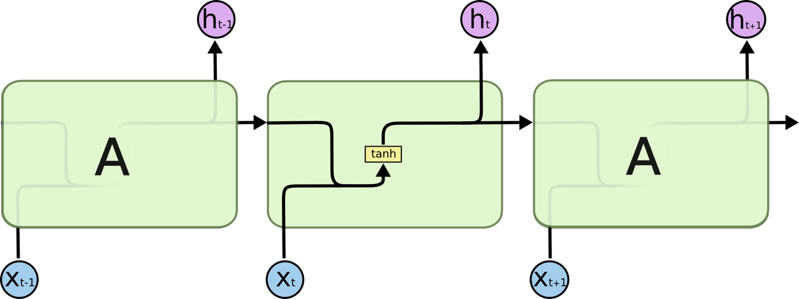

**The repeating module in a standard RNN contains a single layer.**

LSTMs also have this chain like structure, but the repeating module has a different structure. Instead of having a single neural network layer, there are four, interacting in a very special way.

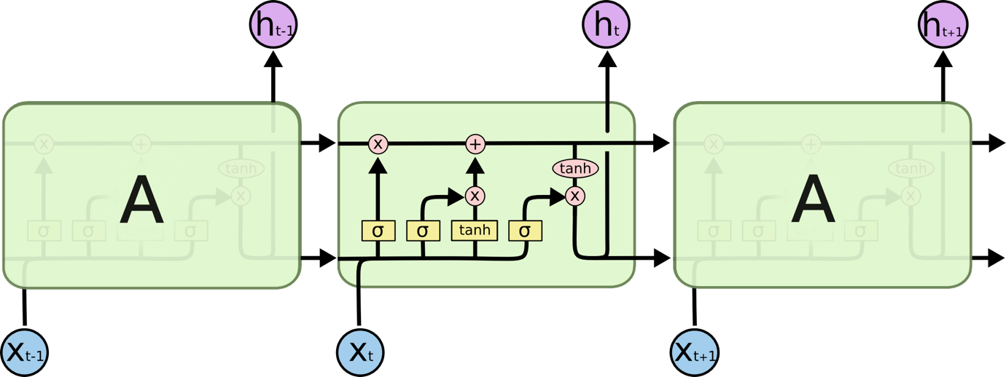

**The repeating module in an LSTM contains four interacting layers.**

Don’t worry about the details of what’s going on. We’ll walk through the LSTM diagram step by step later. For now, let’s just try to get comfortable with the notation we’ll be using.

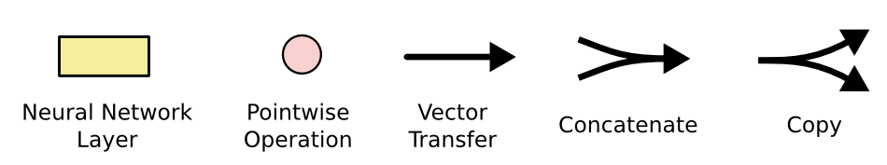

In the above diagram, each line carries an entire vector, from the output of one node to the inputs of others. The pink circles represent pointwise operations, like vector addition, while the yellow boxes are learned neural network layers. Lines merging denote concatenation, while a line forking denote its content being copied and the copies going to different locations.

**The Core Idea Behind LSTMs**

The key to LSTMs is the cell state, the horizontal line running through the top of the diagram.

The cell state is kind of like a conveyor belt. It runs straight down the entire chain, with only some minor linear interactions. It’s very easy for information to just flow along it unchanged.

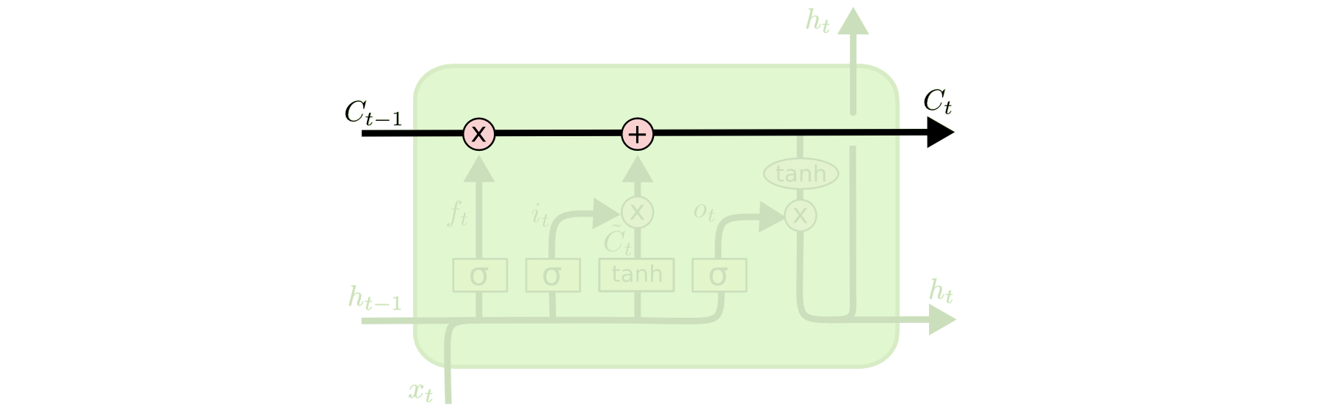

The LSTM does have the ability to remove or add information to the cell state, carefully regulated by structures called gates.

Gates are a way to optionally let information through. They are composed out of a sigmoid neural net layer and a pointwise multiplication operation.



The sigmoid layer outputs numbers between zero and one, describing how much of each component should be let through. A value of zero means “let nothing through,” while a value of one means “let everything through!”

An LSTM has three of these gates, to protect and control the cell state.

**Step-by-Step LSTM Walk Through**

The first step in our LSTM is to decide what information we’re going to throw away from the cell state. This decision is made by a sigmoid layer called the “forget gate layer.” It looks at *ht*−1

and *xt*, and outputs a number between 0 and 1 for each number in the cell state *Ct*−1. A 1 represents “completely keep this” while a 0

represents “completely get rid of this.”

Let’s go back to our example of a language model trying to predict the next word based on all the previous ones. In such a problem, the cell state might include the gender of the present subject, so that the correct pronouns can be used. When we see a new subject, we want to forget the gender of the old subject.

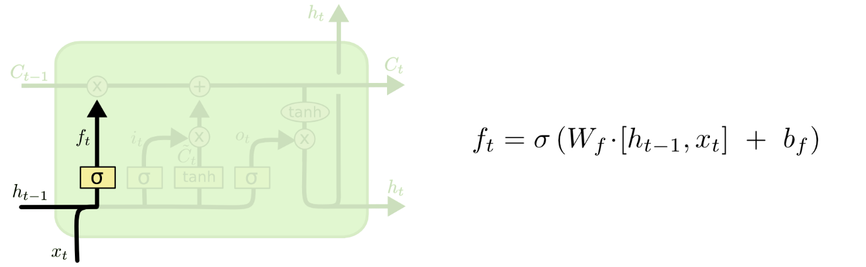

The next step is to decide what new information we’re going to store in the cell state. This has two parts. First, a sigmoid layer called the “input gate layer” decides which values we’ll update. Next, a tanh layer creates a vector of new candidate values, *C*̃ *t*

, that could be added to the state. In the next step, we’ll combine these two to create an update to the state.

In the example of our language model, we’d want to add the gender of the new subject to the cell state, to replace the old one we’re forgetting.

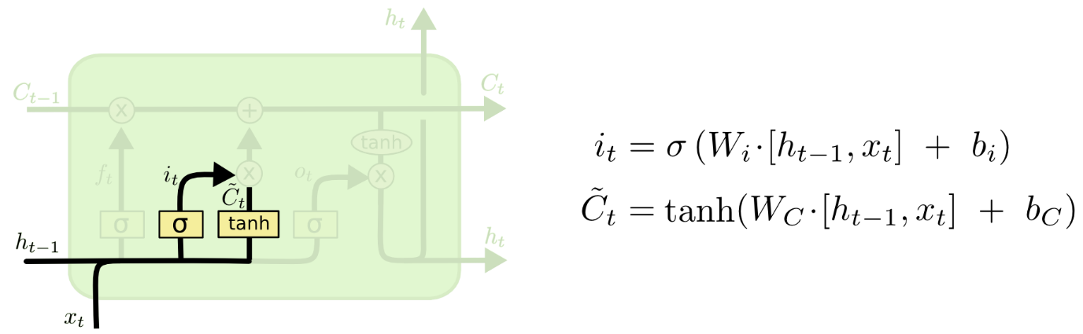

It’s now time to update the old cell state, *Ct*−1

, into the new cell state *Ct*

. The previous steps already decided what to do, we just need to actually do it.

We multiply the old state by *ft*

, forgetting the things we decided to forget earlier. Then we add *it*∗*C*̃ *t*

. This is the new candidate values, scaled by how much we decided to update each state value.

In the case of the language model, this is where we’d actually drop the information about the old subject’s gender and add the new information, as we decided in the previous steps.

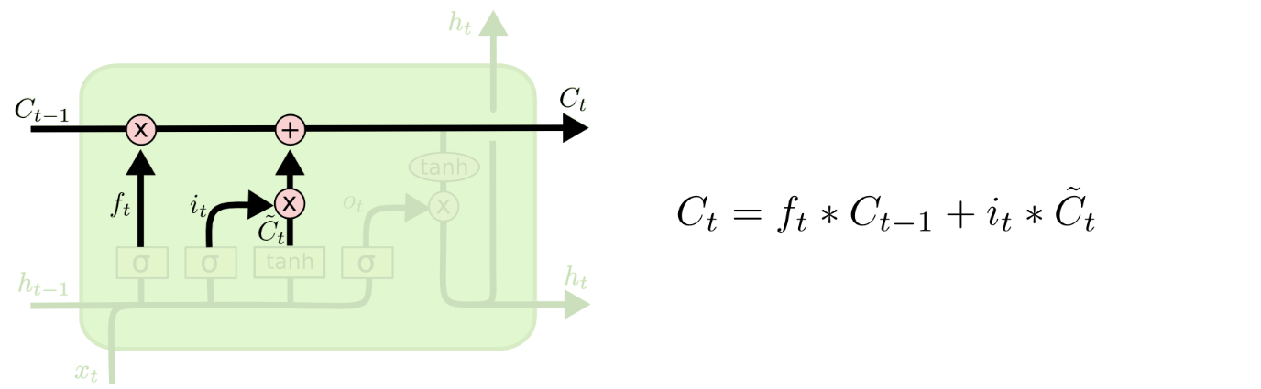

Finally, we need to decide what we’re going to output. This output will be based on our cell state, but will be a filtered version. First, we run a sigmoid layer which decides what parts of the cell state we’re going to output. Then, we put the cell state through tanh

(to push the values to be between −1 and 1

) and multiply it by the output of the sigmoid gate, so that we only output the parts we decided to.

For the language model example, since it just saw a subject, it might want to output information relevant to a verb, in case that’s what is coming next. For example, it might output whether the subject is singular or plural, so that we know what form a verb should be conjugated into if that’s what follows next.

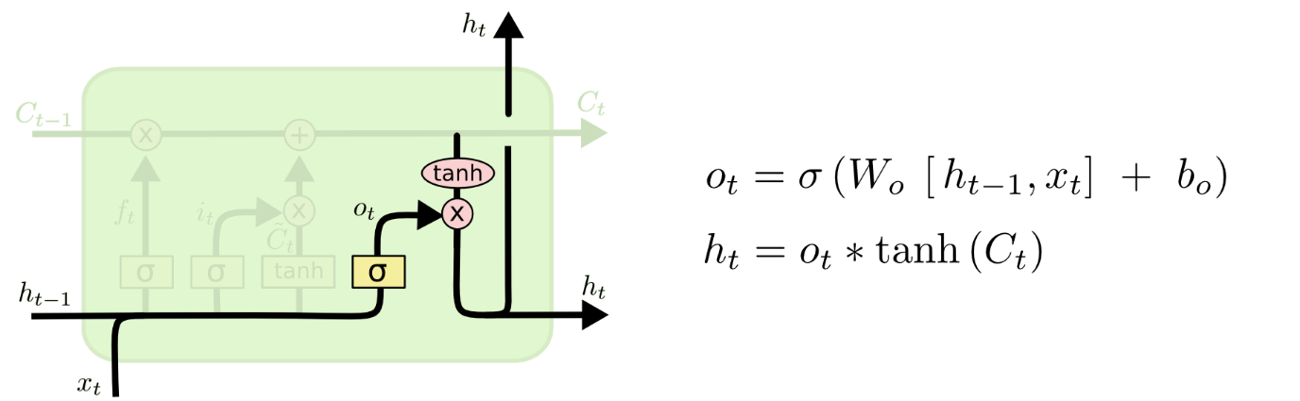

**Variants on Long Short Term Memory**

What I’ve described so far is a pretty normal LSTM. But not all LSTMs are the same as the above. In fact, it seems like almost every paper involving LSTMs uses a slightly different version. The differences are minor, but it’s worth mentioning some of them.

One popular LSTM variant, introduced by [Gers & Schmidhuber (2000)](ftp://ftp.idsia.ch/pub/juergen/TimeCount-IJCNN2000.pdf), is adding “peephole connections.” This means that we let the gate layers look at the cell state.

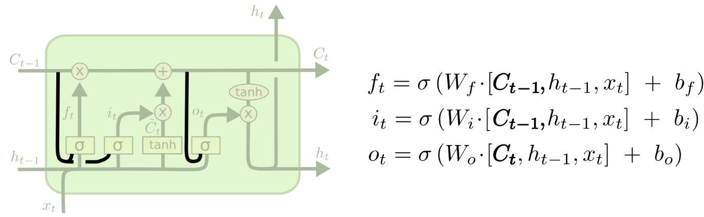

The above diagram adds peepholes to all the gates, but many papers will give some peepholes and not others.

Another variation is to use coupled forget and input gates. Instead of separately deciding what to forget and what we should add new information to, we make those decisions together. We only forget when we’re going to input something in its place. We only input new values to the state when we forget something older.

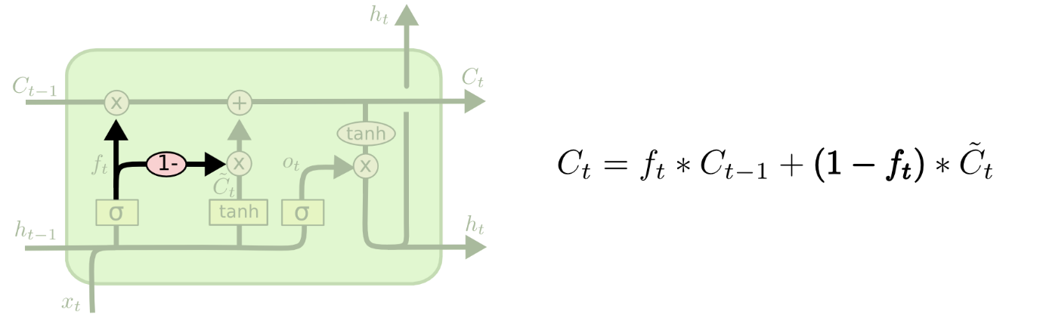

A slightly more dramatic variation on the LSTM is the Gated Recurrent Unit, or GRU, introduced by [Cho, et al. (2014)](http://arxiv.org/pdf/1406.1078v3.pdf). It combines the forget and input gates into a single “update gate.” It also merges the cell state and hidden state, and makes some other changes. The resulting model is simpler than standard LSTM models, and has been growing increasingly popular.

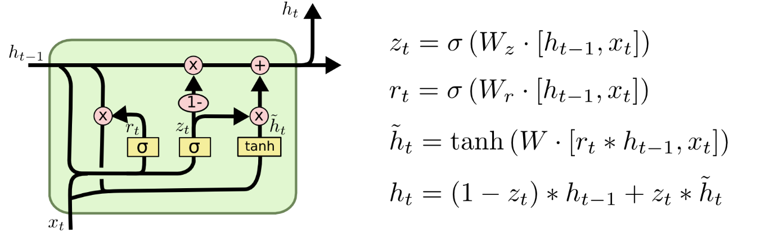

These are only a few of the most notable LSTM variants. There are lots of others, like Depth Gated RNNs by [Yao, et al. (2015)](http://arxiv.org/pdf/1508.03790v2.pdf). There’s also some completely different approach to tackling long-term dependencies, like Clockwork RNNs by [Koutnik, et al. (2014)](http://arxiv.org/pdf/1402.3511v1.pdf).

Which of these variants is best? Do the differences matter? [Greff, et al. (2015)](http://arxiv.org/pdf/1503.04069.pdf) do a nice comparison of popular variants, finding that they’re all about the same. [Jozefowicz, et al. (2015)](http://jmlr.org/proceedings/papers/v37/jozefowicz15.pdf) tested more than ten thousand RNN architectures, finding some that worked better than LSTMs on certain tasks.

**Conclusion**

Earlier, I mentioned the remarkable results people are achieving with RNNs. Essentially all of these are achieved using LSTMs. They really work a lot better for most tasks!

Written down as a set of equations, LSTMs look pretty intimidating. Hopefully, walking through them step by step in this essay has made them a bit more approachable.

LSTMs were a big step in what we can accomplish with RNNs. It’s natural to wonder: is there another big step? A common opinion among researchers is: “Yes! There is a next step and it’s attention!” The idea is to let every step of an RNN pick information to look at from some larger collection of information. For example, if you are using an RNN to create a caption describing an image, it might pick a part of the image to look at for every word it outputs. In fact, [Xu, *et al.* (2015)](http://arxiv.org/pdf/1502.03044v2.pdf) do exactly this – it might be a fun starting point if you want to explore attention! There’s been a number of really exciting results using attention, and it seems like a lot more are around the corner…

Attention isn’t the only exciting thread in RNN research. For example, Grid LSTMs by [Kalchbrenner, *et al.* (2015)](http://arxiv.org/pdf/1507.01526v1.pdf) seem extremely promising. Work using RNNs in generative models – such as [Gregor, *et al.* (2015)](http://arxiv.org/pdf/1502.04623.pdf), [Chung, *et al.* (2015)](http://arxiv.org/pdf/1506.02216v3.pdf), or [Bayer & Osendorfer (2015)](http://arxiv.org/pdf/1411.7610v3.pdf) – also seems very interesting. The last few years have been an exciting time for recurrent neural networks, and the coming ones promise to only be more so!

### LSTM

In a traditional recurrent neural network, during the gradient back-propagation phase, the gradient signal can end up being multiplied a large number of times (as many as the number of timesteps) by the weight matrix associated with the connections between the neurons of the recurrent hidden layer. This means that, the magnitude of weights in the transition matrix can have a strong impact on the learning process.

If the weights in this matrix are small (or, more formally, if the leading eigenvalue of the weight matrix is smaller than 1.0), it can lead to a situation called vanishing gradients where the gradient signal gets so small that learning either becomes very slow or stops working altogether. It can also make more difficult the task of learning long-term dependencies in the data. Conversely, if the weights in this matrix are large (or, again, more formally, if the leading eigenvalue of the weight matrix is larger than 1.0), it can lead to a situation where the gradient signal is so large that it can cause learning to diverge. This is often referred to as exploding gradients.

These issues are the main motivation behind the LSTM model which introduces a new structure called a memory cell (see Figure 1 below). A memory cell is composed of four main elements: an input gate, a neuron with a self-recurrent connection (a connection to itself), a forget gate and an output gate. The self-recurrent connection has a weight of 1.0 and ensures that, barring any outside interference, the state of a memory cell can remain constant from one timestep to another. The gates serve to modulate the interactions between the memory cell itself and its environment. The input gate can allow incoming signal to alter the state of the memory cell or block it. On the other hand, the output gate can allow the state of the memory cell to have an effect on other neurons or prevent it. Finally, the forget gate can modulate the memory cell’s self-recurrent connection, allowing the cell to remember or forget its previous state, as needed.

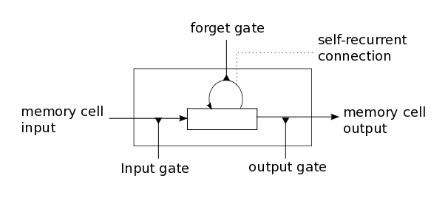

**Figure 1**: Illustration of an LSTM memory cell.

The equations below describe how a layer of memory cells is updated at every timestep . In these equations:

* is the input to the memory cell layer at time 
* , , , , , , , and are weight matrices
* , , and are bias vectors

First, we compute the values for , the input gate, and the candidate value for the states of the memory cells at time :

(1)

(2)

Second, we compute the value for , the activation of the memory cells’ forget gates at time :

(3)

Given the value of the input gate activation , the forget gate activation and the candidate state value , we can compute the memory cells’ new state at time :

(4)

With the new state of the memory cells, we can compute the value of their output gates and, subsequently, their outputs:

(5)

(6)

### Our model

The model we used in this tutorial is a variation of the standard LSTM model. In this variant, the activation of a cell’s output gate does not depend on the memory cell’s state . This allows us to perform part of the computation more efficiently (see the implementation note, below, for details). This means that, in the variant we have implemented, there is no matrix and equation [(5)](http://deeplearning.net/tutorial/lstm.html#equation-5) is replaced by equation [(7)](http://deeplearning.net/tutorial/lstm.html#equation-5-alt):

(7)

Our model is composed of a single LSTM layer followed by an average pooling and a logistic regression layer as illustrated in Figure 2 below. Thus, from an input sequence , the memory cells in the LSTM layer will produce a representation sequence . This representation sequence is then averaged over all timesteps resulting in representation h. Finally, this representation is fed to a logistic regression layer whose target is the class label associated with the input sequence.

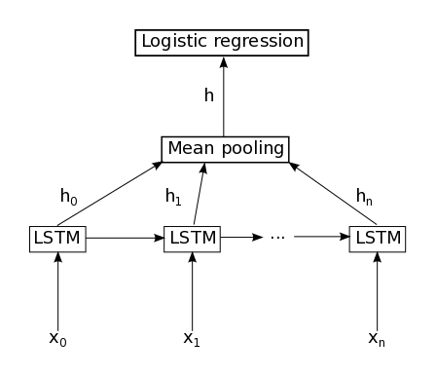

**Figure 2** : Illustration of the model used in this tutorial. It is composed of a single LSTM layer followed by mean pooling over time and logistic regression.

**Implementation note** : In the code included this tutorial, the equations [(1)](http://deeplearning.net/tutorial/lstm.html#equation-1), [(2)](http://deeplearning.net/tutorial/lstm.html#equation-2), [(3)](http://deeplearning.net/tutorial/lstm.html#equation-3) and [(7)](http://deeplearning.net/tutorial/lstm.html#equation-5-alt) are performed in parallel to make the computation more efficient. This is possible because none of these equations rely on a result produced by the other ones. It is achieved by concatenating the four matrices into a single weight matrix and performing the same concatenation on the weight matrices to produce the matrix and the bias vectors to produce the vector . Then, the pre-nonlinearity activations can be computed with:



The result is then sliced to obtain the pre-nonlinearity activations for , , , and and the non-linearities are then applied independently for each.

Artificial Neural Networks

What is a neural network? To get started, I'll explain a type of artificial neuron called a *perceptron*. Perceptrons were [developed](http://books.google.ca/books/about/Principles_of_neurodynamics.html?id=7FhRAAAAMAAJ) in the 1950s and 1960s by the scientist [Frank Rosenblatt](http://en.wikipedia.org/wiki/Frank_Rosenblatt), inspired by earlier [work](http://scholar.google.ca/scholar?cluster=4035975255085082870) by [Warren McCulloch](http://en.wikipedia.org/wiki/Warren_McCulloch) and [Walter Pitts](http://en.wikipedia.org/wiki/Walter_Pitts). Today, it's more common to use other models of artificial neurons - in this book, and in much modern work on neural networks, the main neuron model used is one called the *sigmoid neuron*. We'll get to sigmoid neurons shortly. But to understand why sigmoid neurons are defined the way they are, it's worth taking the time to first understand perceptrons.

So how do perceptrons work? A perceptron takes several binary inputs, x1,x2,…x1,x2,…, and produces a single binary output:

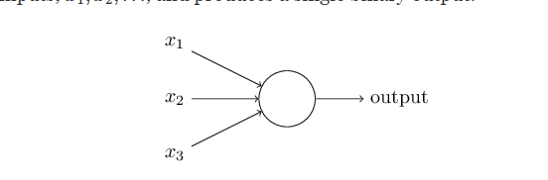

Recurrent Neural Network

In the next section I'll introduce a neural network that can do a pretty good job classifying handwritten digits. In preparation for that, it helps to explain some terminology that lets us name different parts of a network. Suppose we have the network:

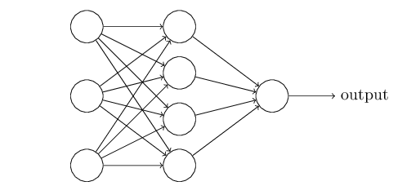

As mentioned earlier, the leftmost layer in this network is called the input layer, and the neurons within the layer are called input neurons. The rightmost or output layer contains the output neurons, or, as in this case, a single output neuron. The middle layer is called a hidden layer, since the neurons in this layer are neither inputs nor outputs. The term "hidden" perhaps sounds a little mysterious - the first time I heard the term I thought it must have some deep philosophical or mathematical significance - but it really means nothing more than "not an input or an output". The network above has just a single hidden layer, but some networks have multiple hidden layers. For example, the following four-layer network has two hidden layers:

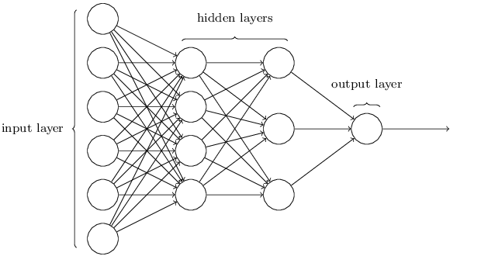

Somewhat confusingly, and for historical reasons, such multiple layer networks are sometimes called *multilayer perceptrons* or*MLPs*, despite being made up of sigmoid neurons, not perceptrons. I'm not going to use the MLP terminology in this book, since I think it's confusing, but wanted to warn you of its existence.

The design of the input and output layers in a network is often straightforward. For example, suppose we're trying to determine whether a handwritten image depicts a "9" or not. A natural way to design the network is to encode the intensities of the image pixels into the input neurons. If the image is a 6464 by 6464 greyscale image, then we'd have 4,096=64×644,096=64×64 input neurons, with the intensities scaled appropriately between 00 and 11. The output layer will contain just a single neuron, with output values of less than 0.50.5 indicating "input image is not a 9", and values greater than 0.50.5 indicating "input image is a 9 ".

While the design of the input and output layers of a neural network is often straightforward, there can be quite an art to the design of the hidden layers. In particular, it's not possible to sum up the design process for the hidden layers with a few simple rules of thumb. Instead, neural networks researchers have developed many design heuristics for the hidden layers, which help people get the behaviour they want out of their nets. For example, such heuristics can be used to help determine how to trade off the number of hidden layers against the time required to train the network. We'll meet several such design heuristics later in this book.

Up to now, we've been discussing neural networks where the output from one layer is used as input to the next layer. Such networks are called *feedforward* neural networks. This means there are no loops in the network - information is always fed forward, never fed back. If we did have loops, we'd end up with situations where the input to the σσ function depended on the output. That'd be hard to make sense of, and so we don't allow such loops.

However, there are other models of artificial neural networks in which feedback loops are possible. These models are called[recurrent neural networks](http://en.wikipedia.org/wiki/Recurrent_neural_network). The idea in these models is to have neurons which fire for some limited duration of time, before becoming quiescent. That firing can stimulate other neurons, which may fire a little while later, also for a limited duration. That causes still more neurons to fire, and so over time we get a cascade of neurons firing. Loops don't cause problems in such a model, since a neuron's output only affects its input at some later time, not instantaneously.

Recurrent neural nets have been less influential than feedforward networks, in part because the learning algorithms for recurrent nets are (at least to date) less powerful. But recurrent networks are still extremely interesting. They're much closer in spirit to how our brains work than feedforward networks. And it's possible that recurrent networks can solve important problems which can only be solved with great difficulty by feedforward networks. However, to limit our scope, in this book we're going to concentrate on the more widely-used feedforward networks.

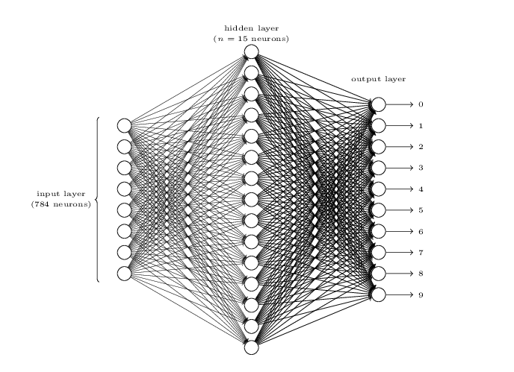

The input layer of the network contains neurons encoding the values of the input pixels. As discussed in the next section, our training data for the network will consist of many 2828 by 2828 pixel images of scanned handwritten digits, and so the input layer contains 784=28×28784=28×28 neurons. For simplicity I've omitted most of the 784784 input neurons in the diagram above. The input pixels are greyscale, with a value of 0.00.0 representing white, a value of 1.01.0representing black, and in between values representing gradually darkening shades of grey.

The second layer of the network is a hidden layer. We denote the number of neurons in this hidden layer by nn, and we'll experiment with different values for nn. The example shown illustrates a small hidden layer, containing just n=15n=15 neurons.

The output layer of the network contains 10 neurons. If the first neuron fires, i.e., has an output ≈1≈1, then that will indicate that the network thinks the digit is a 00. If the second neuron fires then that will indicate that the network thinks the digit is a 11. And so on. A little more precisely, we number the output neurons from 00 through 99, and figure out which neuron has the highest activation value. If that neuron is, say, neuron number 66, then our network will guess that the input digit was a 66. And so on for the other output neurons.

You might wonder why we use 1010 output neurons. After all, the goal of the network is to tell us which digit (0,1,2,…,90,1,2,…,9) corresponds to the input image. A seemingly natural way of doing that is to use just 44 output neurons, treating each neuron as taking on a binary value, depending on whether the neuron's output is closer to 00 or to 11. Four neurons are enough to encode the answer, since 24=1624=16 is more than the 10 possible values for the input digit. Why should our network use 1010 neurons instead? Isn't that inefficient? The ultimate justification is empirical: we can try out both network designs, and it turns out that, for this particular problem, the network with 1010output neurons learns to recognize digits better than the network with 44 output neurons. But that leaves us wondering *why* using 1010output neurons works better. Is there some heuristic that would tell us in advance that we should use the 1010-output encoding instead of the 44-output encoding?

To understand why we do this, it helps to think about what the neural network is doing from first principles. Consider first the case where we use 1010 output neurons. Let's concentrate on the first output neuron, the one that's trying to decide whether or not the digit is a 00. It does this by weighing up evidence from the hidden layer of neurons. What are those hidden neurons doing? Well, just suppose for the sake of argument that the first neuron in the hidden

**Backpropagation through Time**

The recurrent structure makes traditional backpropagation infeasible because of that with the recurrent structure, there is not an end point where the backpropagation can stop. Intuitively, one solution is to unfold the recurrent structure and expand it as a feedforward neural network with certain time steps and then apply traditional backpropagation

onto this unfolded neural network. This solution is known as Backpropagation through Time

(BPTT), independently invented by several researchers including (Robinson and Fallside,1987; Werbos, 1988; Mozer, 1989)

However, as recurrent neural network usually has a more complex cost surface, naïve backpropagation may not work well. Later in this paper, we will see that the recurrent structure introduces some critical problems, for example, the vanishing gradient problem, which makes optimization for RNN a great challenge in the society.

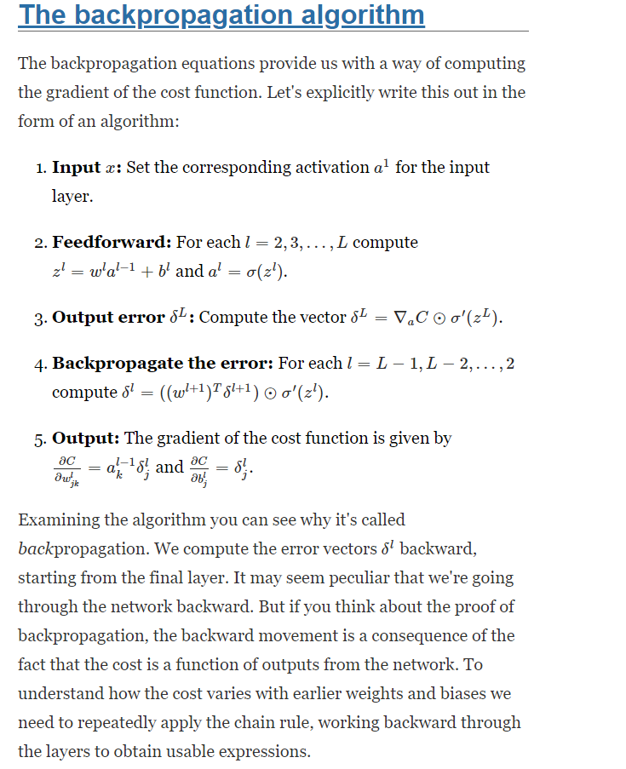

**Vanishing Gradient**

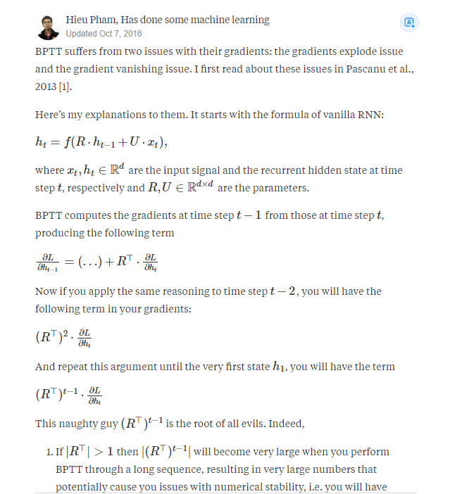

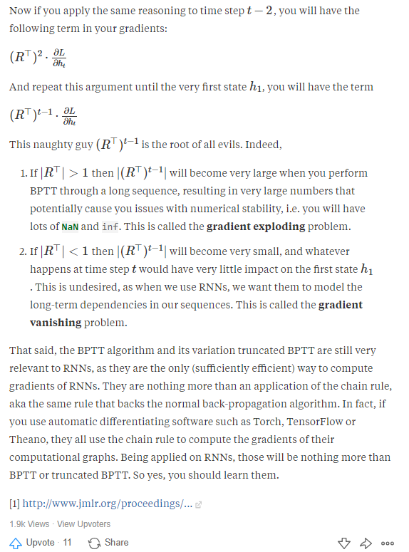

**LTSM**

Another breakthrough in RNN family was introduced in the same year as BRNN. Hochreiter and Schmidhuber (1997) introduced a new neuron for RNN family, named Long Short-Term Memory (LSTM). When it was invented, the term “LSTM” is used to refer the algorithm that is designed to overcome vanishing gradient problem, with the help of a special designed

memory cell

LSTM is widely used to denote any recurrent network that

with that memory cell, which is nowadays referred as an LSTM cell.

LSTM was introduced to overcome the problem that RNNs cannot long term dependencies (Bengio et al., 1994). To overcome this issue, it requires the specially designed memory cell, as illustrated in Figure 24 (a).

LSTM consists of several critical components

Distinction between Markov Chains and RNN

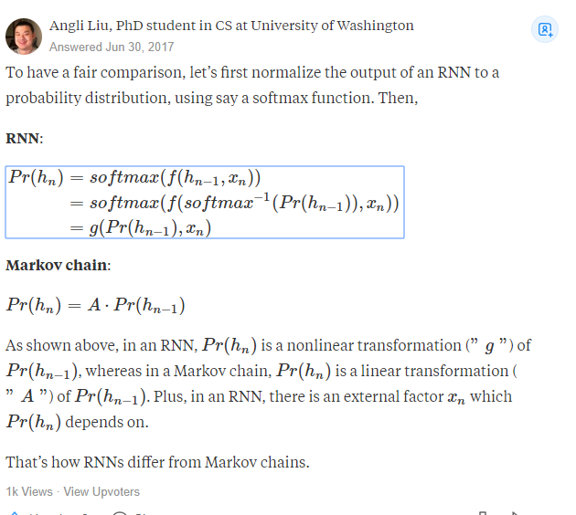

I suspect this is because fittedvalues are predictions of the differenced series. If you want predictions in terms of the original series, you can do:

**Adam Optimizer**

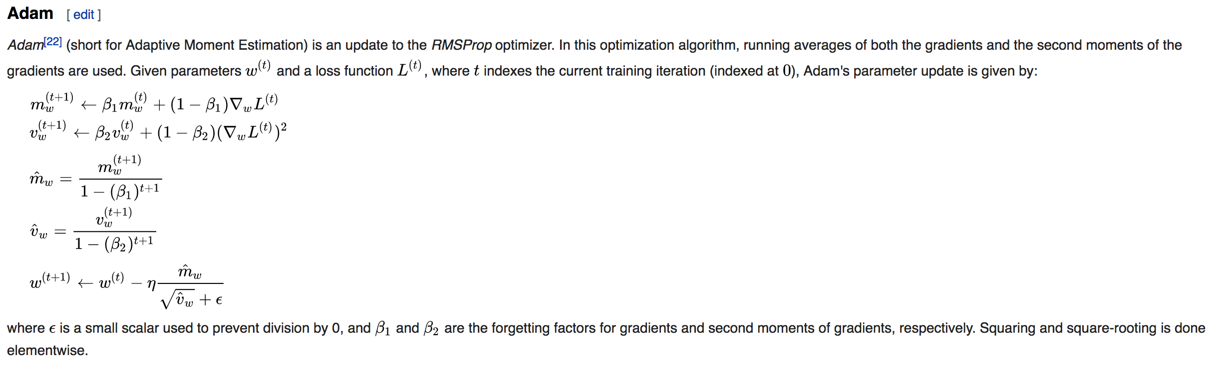

fittedvalues = res.predict(typ='levels')



Batch size determination

too small and you risk making your learning too stochastic, faster but will converge to unreliable models, too big and it wont fit into memory and still take ages.

In the neural network terminology:

* one **epoch** = one forward pass and one backward pass of *all* the training examples
* **batch size** = the number of training examples in one forward/backward pass. The higher the batch size, the more memory space you'll need.
* number of **iterations** = number of passes, each pass using [batch size] number of examples. To be clear, one pass = one forward pass + one backward pass (we do not count the forward pass and backward pass as two different passes).

Example: if you have 1000 training examples, and your batch size is 500, then it will take 2 iterations to complete 1 epoch.

When **solving** with a CPU an **Optimization Problem**, you **Iteratively apply** an **Algorithm** **over** some Input **Data**. In each of these iterations you usually update a Metric of your problem **doing** some **Calculations** **on** the **Data**. Now **when** the size of your **data** is **large** it might **need** a **considerable** amount of **time** to complete every iteration, **and** may consume a lot of **resources**. **So** sometimes you choose to **apply** these iterative **calculations** **on** a **Portion** **of** the **Data** to save time and computational resources. This portion is the batch_size and the process is called (in the Neural Network Lingo) batch data processing. When you apply your computations on all your data, then you do online data processing. I guess the terminology comes from the 60s, and even before. Does anyone remember the .bat DOS files? But of course the concept incarnated to mean a thread or portion of the data to be used.

Glossary

**Batch size** is a term used in machine learning and refers to the number of training examples utilised in one iteration. The **batch size** can be one of three options: **batch** mode: where the **batch size** is equal to the total dataset thus making the iteration and **epoch** values equivalent.

Data Collection and Analysis

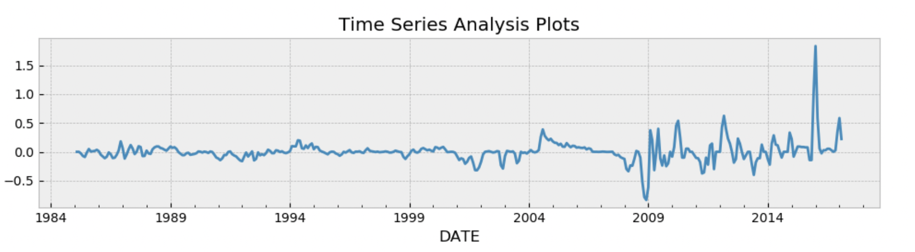

**Arima**



**Gold**

N Tit Tnf Tnint Skip Nact Projg F

7 32 44 1 0 0 7.971D-06 4.002D-01

F = 0.40015816098128437

CONVERGENCE: REL_REDUCTION_OF_F_<=_FACTR*EPSMCH

Cauchy time 0.000E+00 seconds.

Subspace minimization time 0.000E+00 seconds.

Line search time 0.000E+00 seconds.

Total User time 0.000E+00 seconds.

AIC of ARIMA model 18.7541909920376

Params of ARIMA model (0, 0, 1)

AIC of ARIMA model -71.6646402740169

Params of ARIMA model (0, 0, 1)

AIC of ARIMA model -71.6646402740169

Params of ARIMA model (0, 0, 1)

ARMA Model Results

==============================================================================

Dep. Variable: Gold_ret No. Observations: 25

Model: ARMA(0, 1) Log Likelihood 38.832

Method: css-mle S.D. of innovations 0.048

Date: Thu, 03 Jan 2019 AIC -71.665

Time: 11:00:01 BIC -68.008

Sample: 02-01-2015 HQIC -70.650

- 02-01-2017

==================================================================================

coef std err z P>|z| [0.025 0.975]

----------------------------------------------------------------------------------

const 0.0043 0.019 0.231 0.820 -0.033 0.041

ma.L1.Gold_ret 1.0000 0.379 2.637 0.015 0.257 1.743

Roots

=============================================================================

Real Imaginary Modulus Frequency

-----------------------------------------------------------------------------

MA.1 -1.0000 +0.0000j 1.0000 0.5000

-----------------------------------------------------------------------------

Differenced to account for ( normailisation etc)

**VAR**





**<statsmodels.tsa.vector_ar.var_model.LagOrderResults object. Selected orders are: AIC -> 9, BIC -> 3, FPE -> 7, HQIC -> 5>**

**Summary of Regression Results**

==================================

Model: VAR

Method: OLS

Date: Thu, 03, Jan, 2019

Time: 11:31:32

--------------------------------------------------------------------

No. of Equations: 4.00000 BIC: -27.3445

Nobs: 381.000 HQIC: -27.7690

Log likelihood: 3248.71 FPE: 6.59078e-13

AIC: -28.0482 Det(Omega_mle): 5.53483e-13

--------------------------------------------------------------------

Results for equation Gold_ret

======================================================================================

coefficient std. error t-stat prob

--------------------------------------------------------------------------------------

const 0.008636 0.004346 1.987 0.047

L1.Gold_ret 0.650066 0.051679 12.579 0.000

L1.DJI_ret -0.058222 0.052817 -1.102 0.270

L1.Inflation_ret 4.015393 0.961050 4.178 0.000

L1.InterestRate_ret 0.032528 0.020431 1.592 0.111

L2.Gold_ret -0.499789 0.059456 -8.406 0.000

L2.DJI_ret 0.079741 0.063919 1.248 0.212

L2.Inflation_ret -6.336676 1.418276 -4.468 0.000

L2.InterestRate_ret -0.056659 0.027531 -2.058 0.040

L3.Gold_ret 0.316060 0.059173 5.341 0.000

L3.DJI_ret -0.017203 0.063589 -0.271 0.787

L3.Inflation_ret 4.047536 1.441687 2.807 0.005

L3.InterestRate_ret 0.056032 0.027490 2.038 0.042

L4.Gold_ret -0.140640 0.051525 -2.730 0.006

L4.DJI_ret 0.035415 0.052641 0.673 0.501

L4.Inflation_ret -2.515930 0.988592 -2.545 0.011

L4.InterestRate_ret -0.040422 0.020322 -1.989 0.047

======================================================================================

**Correlation matrix of residuals**

Gold_ret DJI_ret Inflation_ret InterestRate_ret

Gold_ret 1.000000 -0.128326 0.072135 -0.071961

DJI_ret -0.128326 1.000000 0.090063 0.115225

Inflation_ret 0.072135 0.090063 1.000000 0.086129

InterestRate_ret -0.071961 0.115225 0.086129 1.000000

rmse 238.01521006034054

mse 56651.24022006804

mse_log 0.03317009614943625

rsquared -6.330709837631952

mae 218.71415906552355





Summary of Regression Results

==================================

Model: VAR

Method: OLS

Date: Wed, 02, Jan, 2019

Time: 15:11:56

--------------------------------------------------------------------

No. of Equations: 4.00000 BIC: -27.3445

Nobs: 381.000 HQIC: -27.7690

Log likelihood: 3248.71 FPE: 6.59078e-13

AIC: -28.0482 Det(Omega_mle): 5.53483e-13

--------------------------------------------------------------------

Results for equation Gold_ret

======================================================================================

coefficient std. error t-stat prob

--------------------------------------------------------------------------------------

const 0.008636 0.004346 1.987 0.047

L1.Gold_ret 0.650066 0.051679 12.579 0.000

L1.DJI_ret -0.058222 0.052817 -1.102 0.270

L1.Inflation_ret 4.015393 0.961050 4.178 0.000

L1.InterestRate_ret 0.032528 0.020431 1.592 0.111

L2.Gold_ret -0.499789 0.059456 -8.406 0.000

L2.DJI_ret 0.079741 0.063919 1.248 0.212

L2.Inflation_ret -6.336676 1.418276 -4.468 0.000

L2.InterestRate_ret -0.056659 0.027531 -2.058 0.040

L3.Gold_ret 0.316060 0.059173 5.341 0.000

L3.DJI_ret -0.017203 0.063589 -0.271 0.787

L3.Inflation_ret 4.047536 1.441687 2.807 0.005

L3.InterestRate_ret 0.056032 0.027490 2.038 0.042

L4.Gold_ret -0.140640 0.051525 -2.730 0.006

L4.DJI_ret 0.035415 0.052641 0.673 0.501

L4.Inflation_ret -2.515930 0.988592 -2.545 0.011

L4.InterestRate_ret -0.040422 0.020322 -1.989 0.047

======================================================================================

Results for equation DJI_ret

======================================================================================

coefficient std. error t-stat prob

--------------------------------------------------------------------------------------

const 0.009659 0.004303 2.245 0.025

L1.Gold_ret -0.028153 0.051173 -0.550 0.582

L1.DJI_ret 0.783710 0.052301 14.985 0.000

L1.Inflation_ret 0.767571 0.951650 0.807 0.420

L1.InterestRate_ret -0.027244 0.020231 -1.347 0.178

L2.Gold_ret 0.092902 0.058875 1.578 0.115

L2.DJI_ret -0.596028 0.063293 -9.417 0.000

L2.Inflation_ret -1.393290 1.404404 -0.992 0.321

L2.InterestRate_ret 0.011970 0.027261 0.439 0.661

L3.Gold_ret -0.068801 0.058594 -1.174 0.240

L3.DJI_ret 0.379651 0.062967 6.029 0.000

L3.Inflation_ret 1.797281 1.427586 1.259 0.208

L3.InterestRate_ret 0.023346 0.027221 0.858 0.391

L4.Gold_ret 0.012465 0.051021 0.244 0.807

L4.DJI_ret -0.191257 0.052126 -3.669 0.000

L4.Inflation_ret -1.022769 0.978923 -1.045 0.296

L4.InterestRate_ret 0.005947 0.020123 0.296 0.768

======================================================================================

Results for equation Inflation_ret

======================================================================================

coefficient std. error t-stat prob

--------------------------------------------------------------------------------------

const 0.001625 0.000231 7.050 0.000

L1.Gold_ret -0.001496 0.002741 -0.546 0.585

L1.DJI_ret 0.001814 0.002802 0.648 0.517

L1.Inflation_ret 1.259641 0.050978 24.710 0.000

L1.InterestRate_ret -0.000106 0.001084 -0.098 0.922

L2.Gold_ret 0.001513 0.003154 0.480 0.631

L2.DJI_ret -0.000030 0.003391 -0.009 0.993

L2.Inflation_ret -1.051248 0.075231 -13.974 0.000

L2.InterestRate_ret -0.001245 0.001460 -0.852 0.394

L3.Gold_ret -0.000107 0.003139 -0.034 0.973

L3.DJI_ret 0.001247 0.003373 0.370 0.712

L3.Inflation_ret 0.680042 0.076473 8.893 0.000

L3.InterestRate_ret 0.000944 0.001458 0.647 0.518

L4.Gold_ret 0.001915 0.002733 0.701 0.484

L4.DJI_ret 0.001716 0.002792 0.615 0.539

L4.Inflation_ret -0.282876 0.052439 -5.394 0.000

L4.InterestRate_ret 0.000247 0.001078 0.229 0.819

======================================================================================

Results for equation InterestRate_ret

======================================================================================

coefficient std. error t-stat prob

--------------------------------------------------------------------------------------

const 0.008368 0.011078 0.755 0.450

L1.Gold_ret -0.221161 0.131736 -1.679 0.093

L1.DJI_ret 0.302329 0.134638 2.245 0.025

L1.Inflation_ret 3.949168 2.449843 1.612 0.107

L1.InterestRate_ret 0.982766 0.052082 18.870 0.000

L2.Gold_ret 0.270268 0.151562 1.783 0.075

L2.DJI_ret -0.218111 0.162937 -1.339 0.181

L2.Inflation_ret -1.771028 3.615375 -0.490 0.624

L2.InterestRate_ret -0.662350 0.070180 -9.438 0.000

L3.Gold_ret -0.092487 0.150839 -0.613 0.540

L3.DJI_ret 0.097895 0.162096 0.604 0.546

L3.Inflation_ret -4.163204 3.675052 -1.133 0.257

L3.InterestRate_ret 0.467905 0.070077 6.677 0.000

L4.Gold_ret 0.029715 0.131343 0.226 0.821

L4.DJI_ret -0.029013 0.134188 -0.216 0.829

L4.Inflation_ret -0.126247 2.520052 -0.050 0.960

L4.InterestRate_ret -0.188184 0.051803 -3.633 0.000

======================================================================================

Correlation matrix of residuals

Gold_ret DJI_ret Inflation_ret InterestRate_ret

Gold_ret 1.000000 -0.128326 0.072135 -0.071961

DJI_ret -0.128326 1.000000 0.090063 0.115225

Inflation_ret 0.072135 0.090063 1.000000 0.086129

InterestRate_ret -0.071961 0.115225 0.086129 1.000000





Deep Regression

LSTM

CNN

Rmse optimiser

Adam optimizer

Training loss



References

https://stackoverflow.com/questions/3775032/how-to-update-the-bias-in-neural-network-backpropagation

<http://neuralnetworksanddeeplearning.com/chap1.html>

<https://onlinelibrary.wiley.com/doi/pdf/10.1002/asmb.2209>

<https://www.itsnotyouitsyourdata.com/undergraduates/msc-dissertation-structure-and-word-counts/>

<https://www.superdatascience.com/recurrent-neural-networks-rnn-long-short-term-memory-lstm/>

<https://www.google.com/search?rlz=1C1GCEA_enGB825GB825&biw=1601&bih=910&tbm=isch&sa=1&ei=UpEzXJHGI7CR1fAPgfWXqA8&q=lstm+pipelines&oq=lstm+pipelines&gs_l=img.3...34120.36227..36442...0.0..0.58.271.6......1....1..gws-wiz-img.......0j0i67j0i7i30.CBE0DFGyppA#imgrc=ntbX2gg0PPN8yM>:

<https://www.quora.com/What-are-the-most-important-deep-learning-algorithms-In-which-order-should-I-learn-them>

<https://machinelearningmastery.com/recurrent-neural-network-algorithms-for-deep-learning/>

<http://colah.github.io/posts/2015-08-Understanding-LSTMs/>

<https://towardsdatascience.com/deep-learning-in-finance-9e088cb17c03>

https://machinelearningmastery.com/time-series-forecasting-long-short-term-memory-network-python/

https://machinelearningmastery.com/tune-lstm-hyperparameters-keras-time-series-forecasting/